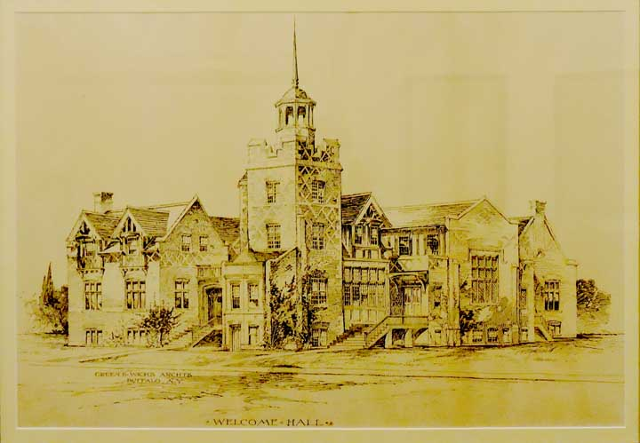  
**Welcome Hall.**  
  Built 1897 at 404-408 Seneca St. as a mission ... "Because of the economics of the times; the church was forced to give up the mission of Welcome Hall following the retirement of Rev. William E. McLennan, who had been the director since 1909. The building and mission was sold to the City of Buffalo where it remained in operation as a community center before being closed and torn down a few years later." -  Bruce McCausland, [1887-2012 History of the First Presbyterian Church](http://buffaloah.com/a/sym/1/mcc.html)

